**The Work Ahead for Intellectual and Developmental Disabilities Research**

Sara T. Kover1 and Leonard Abbeduto2

1University of Washington

2University of California, Davis

**Abstract**

In “Toward Equity in Research on Intellectual and Developmental Disabilities,” we sought to make entrenched assumptions and practices of IDD research visible by explicitly describing the status quo in terms of models of disability, participant and researcher identities, research priorities, and biases in measurement and treatment approaches. We then curated individual- and systems-level actions drawn from disability justice and broader social justice lenses to offer a way forward. We focused on three major areas (i.e., intersectionality and person-centered approaches, participatory research, and interprofessional collaboration), depicting influences, methods, and actions in a framework on disability, identity, and culture. In this Author Response, we address five commentaries that critique and extend that synthesis.

**Corresponding Author**:

Sara T. Kover, Ph.D.

Email address: skover@uw.edu

University of Washington

Speech and Hearing Sciences

1417 NE 42nd St.

Seattle, WA 98105

Leonard Abbeduto, Ph.D., MIND Institute and Department of Psychiatry and Behavioral Sciences, University of California, Davis, Sacramento, California, 95817

**Acknowledgements:** STK and LA acknowledge grant support from the National Institutes of Health: R21DC017226 and P50HD103526, respectively.

The motivation for providing an integrated framework to synthesize the impacts of biased conceptualizations and practices related to intellectual and developmental disabilities (IDD) research (e.g., ableism, racism) was to spark prolonged discussion and accelerate progress toward equity in IDD research. Although we made some concrete suggestions for change, we understood from the outset that our synthesis would be imperfect, filtered through our own experiential lens, and incomplete in its attempt to capture the breadth and depth of scholarship that could shape, or is already shaping, IDD research. Five thoughtful commentaries, which we address in turn, extend and correct that synthesis and offer perspectives on creating sustained change in the field. Further, the collection of commentaries points to theoretical perspectives and actions that have the potential to transform the institutions that constrain IDD research and dismantle the inequitable assumptions and approaches that are perpetuated in the domains of research training, study conceptualization, study implementation, and dissemination (see Figure 1).

The first three commentaries address the study of disability, race, and intersectionality in IDD research. Belcher, Love, Segal, and Lopez-Arvizu (2023) bring new concepts and actionable strategies, while identifying several limitations in our arguments. First and foremost, they correctly point out that the term “dominant culture” was not defined. We appreciate Belcher et al.’s introduction of the “resource allocation culture/controller” construct. Our intended definition of dominant culture closely follows the American Medical Association (AMA 2021), with added emphasis on disability and language: white, male, non-disabled, hetero-, Christian, wealthy, formally educated, U.S.-born, and general American English-speaking.

We welcome Belcher et al.’s call to adopt a clinical anthropological, or medical anthropological, approach and thereby refocus IDD research questions, hypotheses, and researcher representation (Kasnitz & Shuttleworth, 2001). Such an approach would address oppressive systems and inform how dominant models of IDD research reinforce inequities. Belcher and colleagues also expand the dialogue on race in IDD research, which we treated incompletely. They remind us that without recognizing race as a complex sociopolitical construct, the field will continue to reify research, clinical, and educational practices that perpetuate bias (Johnson et al., 2021; Mallipeddi, 2022).

Johnson’s (2023) commentary calls attention to the need to name whiteness and racialization in efforts to *dismantle* inequitable systems. Johnson also emphasizes that racialization is at the foundation of understanding disability and IDD—a link between racism and how knowledge is generated (Ellis, 2023; Johnson et al., 2021). This same racialization contributes to scholarly neglect and exploitation of multiply marginalized scholars through failure to cite and failure to mentor (Malone et al., 2022; McCoy et al., 2015; Smith & Garrett-Scott, 2021).

Johnson suggests productive anti-racist frameworks for IDD research that take up individual differences that are easily overlooked when using categorical labels (Burks-Abbott, 2022; Fleming et al., 2023). Disability Critical Race Theory (DisCrit), emphasizing the interdependence of racism and ableism, intersectionality, and convergence of whiteness and ability, is an essential theoretical perspective to include in this discussion (Annamma et al., 2013; Malone et al., 2022). In addition to DisCrit, we did not address whiteness and thereby, failed to call out the central role of the harms caused by whiteness in IDD research.

Belcher et al.’s (2023) and Johnson’s (2023) writings speak to the miss in not going beyond self-reflection to collaborate with multiply marginalized individuals with IDD. Even when critiquing our own previous work, respecting the scholarship of multiply marginalized researchers is far from enough. We recognize the impact of saviorism and tourism (Charlton, 2000; Lett et al., 2022, Spanierman & Smith, 2017), acknowledge that the paper is weaker as a result, and view the commentaries as integral to providing critical perspectives.

Bonney and Ellison (2023) bring forward several constructs and strategies, including epistemic injustice and conceptual marginalization. They point out that dominant models of IDD include the consequential, but tacit, assumptions that features of IDD are universal and that cultural variation is “noise or nuisance.” Instead, these commentators suggest working from models of cultural variation and thinking globally to understand individual differences and intersectionality (Mallipeddi, 2022). Critical inquiry and emancipatory research can be particularly useful on this front (Noel, 2016; Petit-McClure, 2019).

Although Bonney and Ellison agree with a focus on increasing community engagement in IDD research, they point out that first, the harms caused by dominant-culture practices need to be acknowledged. We concur and add only that harms should be thoroughly documented, lest they be repeated. On the topic of equitable engagement, Shogren (2022) asks in her AAIDD presidential address, “What if the default in our systems was people with lived experiences being afforded their right to be an equal contributor and a driver of the science (and the policy and practice) that is intended to impact their lives?”

The remaining two commentaries address institutional- and systems-level actions. Thoma and Scott (2023), co-editors of *Inclusion*, offer ideas related to editorial processes–part of the research enterprise we only briefly mentioned. They recommend development of quality indicators for IDD research, which would be particularly useful for manuscript reviewers and journal editors (Bigby et al., 2013). They also reiterate the need for editorial board and grant reviewer training, as well as support from professional organizations and publishers to provide mentoring to individuals with IDD beginning to engage in the review process. Thoma and Scott also emphasize that the type of partnerships necessary for systemic change will require substantial co-training in team science and collaboration, including universal design principles (Kim et al. 2022). Such training and infrastructure should be institutionally supported, by higher education, professional organizations, publishers, and funders (Schwartz et al., 2020; Stack & McDonald, 2018).

From their vantage in the *Eunice Kennedy Shriver* National Institute of Child Health and Human Development (NICHD), King and Parisi’s (2023) commentary articulates NIH’s commitment to representation and inclusivity in IDD research. They point to several initiatives, such as NICHD’s STRIVE (<https://www.nichd.nih.gov/about/org/strive>) and Plans for Enhancing Diverse Perspectives (<https://braininitiative.nih.gov/about/plan-enhancing-diverse-perspectives-pedp>), as well as efforts to reform NIH review processes.

King and Parisi also depict the hurdles to engaging in biomedical research, reminiscent of the leaky pipeline that has been used to portray barriers to participation in higher education (Ellis & Kendall, 2021; Lund, 2021). We agree that those hurdles link to systemic barriers that also lead to unknown generalizability between data collected and diverse populations, and ultimately to the rigor, reproducibility, and validity of IDD research (Thurm et al., 2022).

A critical thread among these commentaries is the need to *center* equity in IDD research. Indeed, King and Parisi highlight the necessity for every member of the IDD research community – not just individuals who are multiply marginalized – to authentically engage. Together, efforts by individuals and in systems will shift the practices and impact of IDD research. This is everyone’s work and the only viable future for IDD research (Havercamp & Bonardi, 2022; Shogren, 2022).

**References**

American Medical Association and Association of American Medical Colleges. Advancing health equity: a guide to language, narrative and concepts. Available at: www.ama-assn.org/equity-guide. Accessed February 15, 2023.

Annamma, S. A., Connor, D., & Ferri, B. (2013). Dis/ability critical race studies (DisCrit): Theorizing at the intersections of race and dis/ability. *Race Ethnicity and Education*, *16*(1), 1-31.

Bigby, C., Frawley, P., & Ramcharan, P. (2014). Conceptualizing inclusive research with people with intellectual disability. *Journal of Applied Research in Intellectual Disabilities, 27*(1), 3-12.

Burks-Abbott, G. (2022). A theory of mine: My perspective on perspective-taking. *Autism in Adulthood*,*4*(4), 265-267.

Charlton, J. I. (2000). *Nothing about us without us: Disability oppression and empowerment*. Univ of California Press.

Ellis, J. (2023). Imagining neurodivergent futures from the belly of the identity machine: Neurodiversity, biosociality, and strategic essentialism. *Autism in Adulthood*, online ahead of print.

Ellis, C., & Kendall, D. (2021). Time to act: Confronting systemic racism in communication sciences and disorders academic training programs. *American Journal of Speech-Language Pathology*, *30*(5), 1916-1924.

Fleming, P. J., Stone, L. C., Creary, M. S., Greene-Moton, E., Israel, B. A., Key, K. D., Reyes, A. G., Wallerstein, N., & Schulz, A. J. (2023). Antiracism and community-based participatory research: Synergies, challenges, and opportunities. *American Journal of Public Health, 113*(1), 70-78.

Havercamp, S. M., & Bonardi, A. (2022). Special Issue Introduction: Addressing Healthcare Inequities in Intellectual Disability and Developmental Disabilities. *Intellectual and Developmental Disabilities*, 60(6), 449-452.

Johnson, K. R., Bogenschutz, M., & Peak, K. (2021). Propositions for race-based research in intellectual and developmental disabilities. *Inclusion*, *9*(3), 156-169.

Kasnitz, D., & Shuttleworth, R. (2001). Introduction: Anthropology in disability studies. *Disability Studies Quarterly*, *21*(3).

Kim, J. H., Hughes, O. E., Demissie, S. A., Kunzier, T. J., Cheung, W. C., Monarrez, E. C., ... & Rossetti, Z. (2022). Lessons Learned from Research Collaboration Among People With and Without Developmental Disabilities. *Intellectual and Developmental Disabilities*, 60(5), 405-415.

Lett, E., Adekunle, D., McMurray, P., Asabor, E. N., Irie, W., Simon, M. A., ... & McLemore, M. R. (2022). Health equity tourism: ravaging the justice landscape. *Journal of medical systems*, *46*(3), 17.

Lund, E. M. (2021). Addressing the leaking pipeline: Supporting disabled graduate student teachers in psychology. *Teaching of Psychology*, 00986283211036420.

Mallipeddi, N. V., & VanDaalen, R. A. (2022). Intersectionality within critical autism studies: A narrative review. *Autism in Adulthood*,*4*(4), 281-289.

Malone, K. M., Pearson, J. N., Palazzo, K. N., Manns, L. D., Rivera, A. Q., & Mason Martin, D. L. (2022). The scholarly neglect of black autistic adults in autism research. *Autism in Adulthood*, *4*(4), 271-280.

McCoy, D. L., Winkle-Wagner, R., & Luedke, C. L. (2015). Colorblind mentoring? Exploring white faculty mentoring of students of color. *Journal of Diversity in Higher Education*, *8*(4), 225.

Noel, L. (2016, June). Promoting an emancipatory research paradigm in Design Education and Practice, in Lloyd, P. and Bohemia, E. (eds.), *Future Focused Thinking - DRS International Conference*, Brighton, United Kingdom.

Petit-McClure, S. H., & Stinson, C. (2019). Disrupting dis/abilization: a critical exploration of research methods to combat white supremacy and ableism in education. *Intersections: Critical Issues in Education*, 3(2), 4.

Schwartz A.E., Kramer, J.M., Cohn, E.S., McDonald, K.E. (2020). "That felt like real engagement": Fostering and maintaining inclusive research collaborations with Individuals with intellectual disability. *Qualitative Health Research, 30*(2), 236-249.

Shogren, K.A. (2022). Presidential address - Dismantling systemic barriers: Re-envisioning equity and inclusion. *Intellectual and Developmental Disabilities,* 60(6), 520–529.

Smith, C. A., & Garrett‐Scott, D. (2021). “We are not named”: Black women and the politics of citation in anthropology. *Feminist Anthropology*, *2*(1), 18-37.

Spanierman, L. B., & Smith, L. (2017). Roles and responsibilities of White allies: Implications for research, teaching, and practice. *The Counseling Psychologist*, *45*(5), 606-617.

Stack, E. E., & McDonald, K. (2018). We are “both in charge, the academics and self‐advocates”: empowerment in community‐based participatory research. *Journal of Policy and Practice in Intellectual Disabilities*, 15(1), 80-89.

Thurm, A., Halladay, A., Mandell, D., Maye, M., Ethridge, S., & Farmer, C. (2022). Making research possible: Barriers and solutions for those with ASD and ID. *Journal of Autism and Developmental Disorders*, *52*(10), 4646-4650.

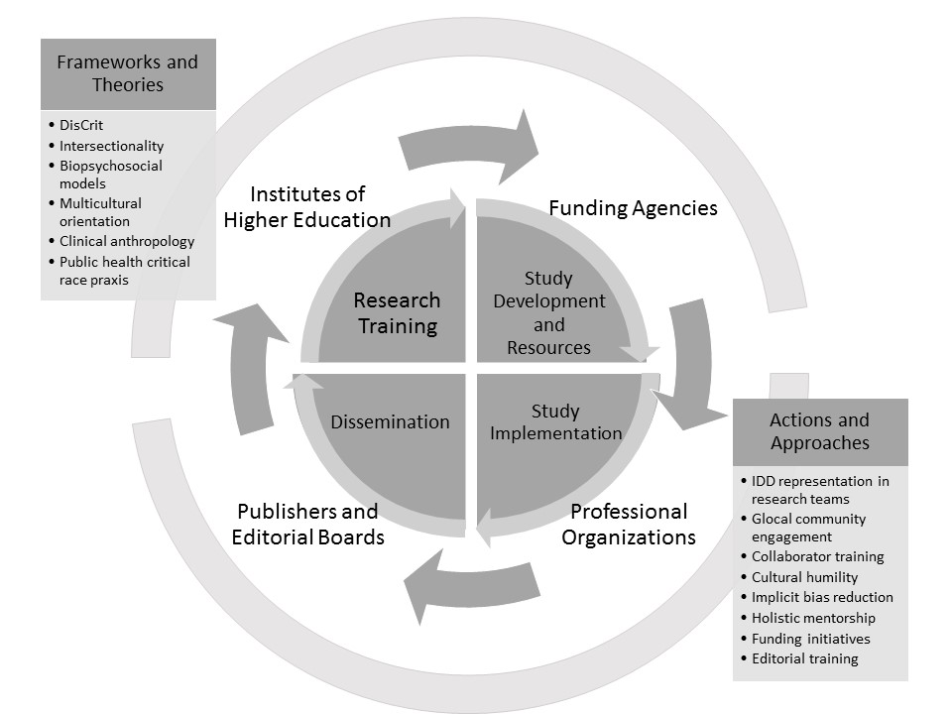

*Figure 1*. Resource-allocating entities (outer ring) and systems and processes (center) that determine the impact of IDD research in the context of frameworks & theories and actions & approaches with the potential to perturb inequitable assumptions and practices (Belcher et al., 2023; Bonney & Elison, 2023; Johnson, 2023; King & Parisi, 2023; Thoma & Scott, 2023).