December 7, 2018

Dear Members,

As a professional society, it is important that our Association reflects our membership. The theme of our annual conference in June was “Reaffirming Diversity and Inclusion” and during my Presidential Address – I posed the following questions: “As a professional organization, do we have diversity in our membership, do we have diversity in our leadership? If not, why not? AAIDD is a place where you can get involved and develop your leadership skills. This room has luminaries in the field, AAIDD past-presidents, board members, fellows, but who will come forward to serve the Association? Our board should represent you, but it can’t if you do not put yourselves forward for leadership roles.” For those that did not attend the conference in St. Louis, my full address can be read here.

I do hope you were able to respond by nominating deserving individuals for board leadership positions and recognition with AAIDD awards too! However, to determine how we are doing in these endeavors, and monitor our progress, we first need to establish baseline data. Presently, we do not collect demographic or diversity related data with our membership platform, so we have no baseline to measure against future data points. To remedy this, we hope you will take a few minutes to provide us some information about you through an anonymous membership survey that will distributed soon.

An organization that is 142 years old cannot remain relevant unless it respects its past whilst evolving and adapting to meet present and future needs. Our newly structured Interest Networks are an example of this, and the structures of our geographic regions are another area in which we are seeking to modernize and adapt for 21st century realities. But for now, please do help us to know more about you, our members!

We have recently celebrated Thanksgiving and as the holiday season approaches, it is important that we stay connected and reconnect with friends, families, and colleagues to celebrate the joyful things in life. As members of AAIDD, we should take time to celebrate the progress we make together, to celebrate our continued advocacy, and reaffirm our commitment to AAIDD’s mission – to promote progressive policies, sound research, effective practices, and universal human rights for people with intellectual and developmental disabilities.

On behalf of the board of directors of AAIDD, I sincerely thank you for your contributions to this mission – and I wish you all a very prosperous 2019!
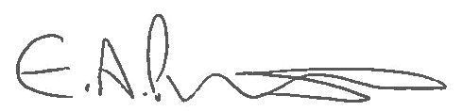

Elizabeth A.Perkins, PhD, RNLD, FAAIDD, FGSA
President, AAIDD Board of Directors

